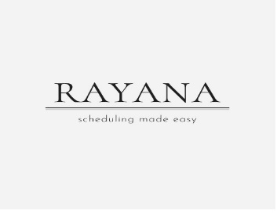
Price list

Tradeprint for resturant calendar:
resturant calendar: 800.opkr
The Tradeprint Restaurant Calendar is a specialized calendar designed for restaurants and hospitality businesses to stay organized throughout the year while showcasing their branding and unique style. It serves as both a practical scheduling tool and a marketing asset, making it ideal for business owners in the food service industry.
IN VERY AFFORDABLE PRIZES;
DISCOUNTED RATE ONLY WEEKLY OFFER


